Latihan Assignment Speech Recognition
The application will show the main menu.
- Audio Augmentation
- Predict Text
- Exit
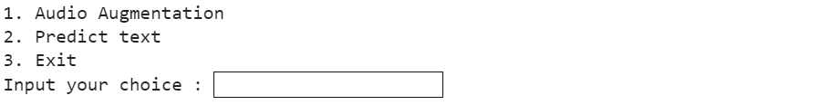
- Menu 1 (Audio Augmentation), the application will show the audio augmentation menu.
- Pitch shift (Increase or decrease pitch)
- Add white noise
- Repeat clip
- Insert fade in
- Back to main menu

- If the user chooses sub-menu 1 (Pitch shift), the application will:
- Ask the user to input the pitch rate. Validate that the input must be between -5 and 5.
- Ask the user to input new file name. Validate that the input must ends with “.wav”.
- Export manipulated audio as new audio file.
- If the user chooses sub-menu 2 (Insert white noise), the application will:
- Ask the user to input noise level to insert white noise. Validate that the input must between 0.1 and 0.5.
- Ask the user to input new file name. Validate that the input must ends with “.wav”.
- Export manipulated audio as new audio file.
- If the user chooses sub-menu 3 (Repeat clip), the application will:
- Ask the user to input how many times the audio should be repeated. Validate that the input must be greater than 0.
- Ask the user to input new file name. Validate that the input must ends with “.wav”.
- Export manipulated audio as new audio file.
- If the user chooses sub-menu 4 (Insert fade in effect), the application will:
- Ask the user to input duration effect to set fade in effect. Validate that the input must more than 0.
- Ask the user to input new file name. Validate that the input must ends with “.wav”.
- Export manipulated audio as new audio file.

- If the user chooses menu 2 (Predict text), the application will predict and print the sound delivered in the form of text with wav2vec2 model and change ‘|’ (vertical bar) to ‘ ’ (whitespace).
